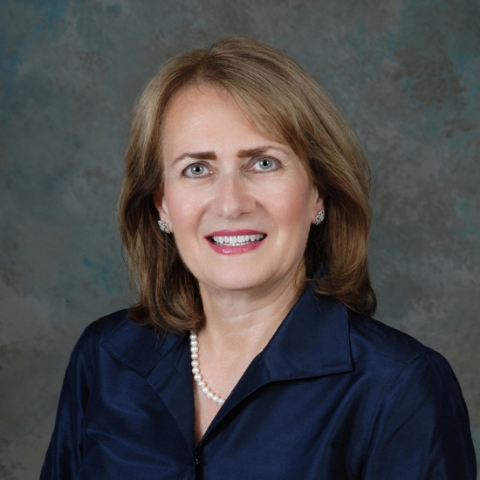

Rosemary Orlando

Professor
Dr. Rosemary Orlando joined SNHU in 1994 and is a professor of TESOL in the Institute for Language Education. Rosemary has been a visiting professor at Vietnam National University in Hanoi for the past four and a half years traveling back and forth between Vietnam and the U.S. numerous times each year to teach courses onsite to Vietnamese English language teachers as part of a joint master's degree program. She also serves as a liaison between SNHU and VNU MS TEFL program administrators.
Orlando received her Bachelor of Arts in Humanities from Providence College, her Master of Education in English as a Second Language from Rhode Island College, and her Doctor of Education from Argosy University, Sarasota, Florida.
Orlando's professional memberships include TESOL (Teachers of English to Speakers of Other Languages) where she served as Chair of the TESOL Awards Committee and is a frequent presenter at the annual international convention, IATEFL (International Association of Teachers of English as a Foreign Language), and NNETESOL (Northern New England Teachers of English to Speakers of Other Languages) where she previously served as President.
Presentations include April 2012, Qatar TESOL, Doha, Qatar, ''Teacher Trainers as Motivators for Effective Cultural Development,'' March 2012 TESOL International Convention Philadelphia, PA, ''Building Community: Culturally Responsive Approaches in Innovative EFL Teacher Education,'' May 2011 Hanoi Academy for Journalism & Communication – Faculty of Foreign Languages - Hanoi, Vietnam, ''New Ways of Teaching English Teachers in Vietnam,'' and May 2011 Hanoi Economic & Technology University, Hanoi, Vietnam,''Approaches in Vietnamese English Language Teaching Techniques.''

