Extensive reading seminar

8.00 - 8.45
Dr Rob Waring - Why everyone should be doing Extensive Reading
This presentation will review of the current state of EFL and recent research reading and vocabulary to highlight the relatively little recycling of vocabulary, the lack of attention to collocation, colligation and lexical phrases in general there is in typical EFL courses and show that Extensive Reading is the missing element in language teaching and learning. The presenter will then show how teachers, students and curriculum designers can provide the missing massive amounts of exposure students need to consolidate their language knowledge to enable long term acquisition to take place.

Break (5 minutes)

8.50 - 9.50
Dr Rob Waring - How to set up and run an Extensive Reading program
This presentation will review the basic principles and aims underlying a successful Extensive Reading program for Vietnamese learners. The presenter will show how to select the right materials, how to create a library, set up borrowing systems, set goals, how to integrate the Extensive Reading into the curriculum and assess the learning.

Break (10 minutes)

10.00 -10.45
Todd Beuckens - How to improve English listening fluency
The presenter will show how extensive listening works very much like extensive reading in that it helps expose students to large amounts of spoken English, thus increasing their vocabulary and grammar with natural acquisition. The presenter will also show how extensive listening and extensive reading differ slightly and how a large exposure to different accents and speakers is essential to language acquisition.

Break (10 minutes)

10.55 -11.40
Paul Goldberg (60 minutes)- The benefits of doing extensive reading online with Xreading
Online extensive reading means much more than students being able to read graded readers on their computers or smartphones whenever and wherever they want. It can put powerful tools like an interactive dictionary, character lists, audio-on-demand, and book ratings, right at their fingertips. Additionally, online extensive reading allows teachers to monitor and track their students’ reading progress including which books their students have selected, how many words they have read, and even their reading speed. In this presentation, the speaker, who developed Xreading, a commercial website for extensive reading, will explain how teachers can get the most out of using online extensive reading with their classes, and give a demonstration of the Xreading system.

Break (5 minutes)

11.45 - 12.15 Q&A

12.15 - 12.30
Give away and summary
The presenters will announce several major prizes on offer ONLY to attendees
- The chance to win 2x $1000 or 6 x $500 donations of books from the ER Foundation for your library - attendees will need a smartphone to enter
- Free sample graded readers
- Free demonstration passes to Xreading.com

Dr. Rob Waring, is Professor at Notre Dame Seishin University in Okayama, Japan. He is an acknowledged expert in Extensive Reading and second language vocabulary acquisition. He has published over 60 articles and has given hundreds of lectures, plenaries and featured speaker presentations in 28 countries. He has been Chair of several major international conferences. He is an Executive Board member of the Extensive Reading Foundation responsible for the promotion of Extensive Reading globally. He is also author and series editor of a six series of graded readers by various publishers. He is the administrator and co-founder of the Extensive Reading website www.ER-Central.com and of www.word-learner.com.

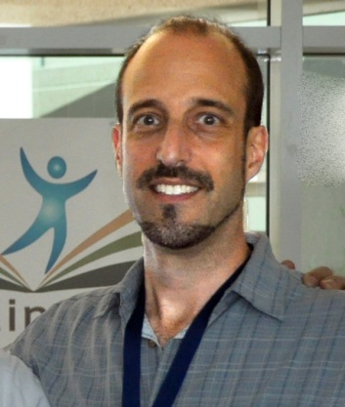 | Paul Goldberg has an MS in Secondary Education, an MA in TESOL and completed the coursework (ABD) for an EdD in TESOL. He has taught English as a foreign language in Venezuela, Spain, Korea, the US, and most recently at Kwansei Gakuin University in Osaka, Japan. His main areas of interest are extensive reading and extensive listening. He is also the founder of Xreading, which he developed because of his desire to make extensive reading more accessible for students and easier for teachers to manage.
 | Todd Beuckens is an ESL teacher with over 20 years experience teaching in Japan, Thailand and the United States. He currently is a lecturer at Ritsumeikan Asia Pacific University in Japan. He is the creator of numerous language learning websides, most notably English Listening Lesson Library Online (elllo.org) which has over 2,000 authentic listening lessons featuring speakers from nearly 100 countries. He has an M.A. from San Diego State in Learning, Design and Technology.

