PROCEDURE OF RECEIVING FOREIGN STUDENTS
(For Credits taking students)
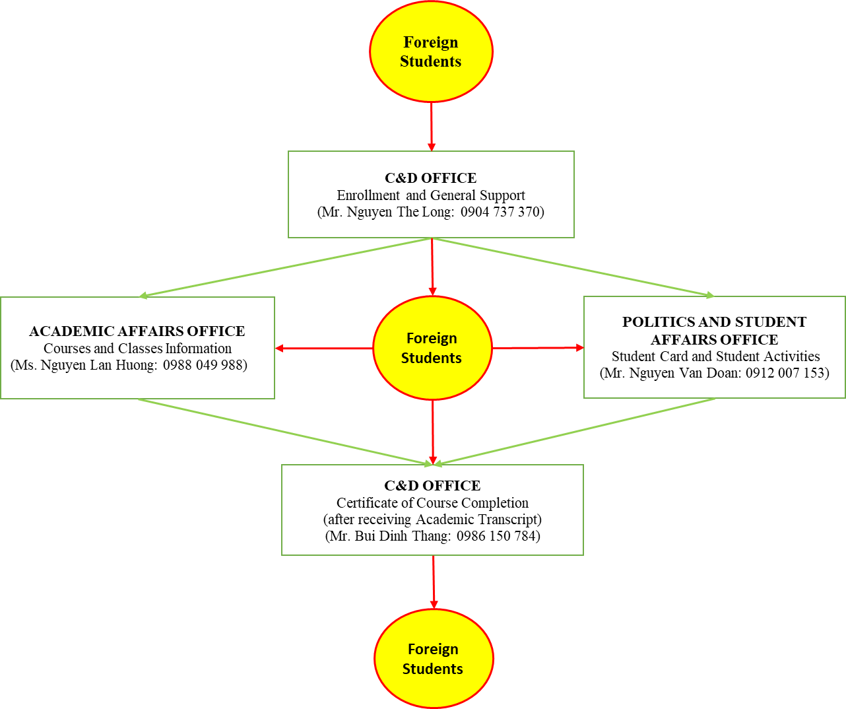

NOTICE FOR FOREIGN STUDENTS (FS)

I. Necessary documents:
1. A copy of Passport (include Passport Photo page, Visa page and entry seal page)
2. Residence Registration Form submits to C&D Office
3. 01 passport photo (size: 4x6 cm)

II. About studying:
During studying period, in case any issue happens, please contact Mr. Nguyen The Long (0904 737 370, C&D Office) or Ms. Nguyen Lan Huong (0988 049 988, Academic Affairs Office) for further support

III. About living:
1. During your time in dormitory, if any problem happens such as: electric cut, water cut, Internet problem…, FS should visit Dormitory Management Office (First floor) for further support. In addition, FS can also contact with Ms. Ngoc Anh – staff of Dormitory Management Office (Phone number: 0902 172 116) or Ms. Nguyen Thi Hanh – staff of C&D Office (Phone number: 0904 712 292)
2. Preserve assets and abide the regulation of dormitory
3. In case of prolonged absence, FS must submit necessary documents at C&D Office. In addition, students, who stay in Dormitory, must inform Dormitory Management Board (via Ms. Ngoc Anh).
Notice: Always stay cautious while travelling in Vietnam, accompanied by your friend if possible
4. Eating street food is not advised
5. In case of illness, contact Mr. Nguyen The Long (Phone number: 0904 737 370) or Ms. Nguyen Thi Hanh (Phone number: 0904 712 292), C&D Office

IV. About transportation:
1. Using motor cycle is not advised
2. Always stay aware of your surroundings while trespassing. Use of pedestrian crossing or pedestrian bridge
3. Stay aware of your important belongings while on public transport (wallet, cell phone, jewelry…)
4. Using Uber or Grab taxi service is recommended

